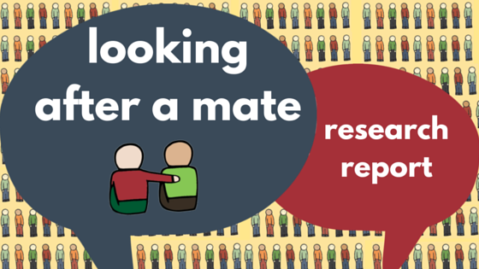

Looking After a Mate Report Launch

Student minds are proud to present our report on the role friends and supporters play to students experiencing mental health difficulties

“This is a really necessary study… I think that students should be supported to support each other since we are not only dealing with each other’s mental health in a stressful environment, but also things like the loss and grief our friends experience.”

Student Minds has now published a full report on the research conducted into the impact friends and supporters have to those experiencing mental health difficulties. The reports aims were to understand the support that students provide to each other by looking into the challenges students face in providing support, their needs as supporters, the support they receive and the impact this responsibility has on their lives.

Seventy nine students supporting a friend with mental health difficulties took part in the study.

Our findings indicated that we should be concerned about the mental wellbeing of supporters and suggests that providing support to a friend may reduce the ability to make the most out of the university experience. The level of support that students provide to peers needs to be recognised and provision should be made to support students taking on this role of an informal supporter. In particular, students supporting peers taking time out of university and students supporting a partner, appear to be particularly vulnerable and may benefit from targeted support.

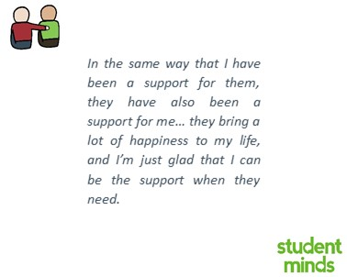
Headline stats

44% of supporters felt that they were the primary source of social support for the supportee

73% of supporters helped arrange formal treatment for the supportee

55% of supporters wanted information from or the opportunity to speak to the professionals supporting the supportee.

47% of supporters were experiencing mental health difficulties.

Key Recommendations

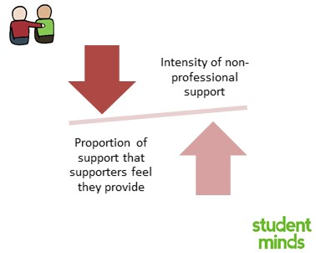
- Increasing the range and intensity of non-professional support (e.g., friends and family) available to students experiencing difficulties reduces the impact of providing support on any one individual.

Many students were supporting a friend who was not receiving any support from professional services. Supporters want more engagement with the professionals supporting their friend.

Student supporters need more support. They may likely to be experiencing their own mental health difficulties. They often feel that they don't know how best to support their friend and this is stressful. Meeting supporters needs can reduce the negative effects of poor mental health on the relationship.

Peer support has always been at the heart of the work Student Minds do and a range of peer support interventions for students. This includes our Look After Your Mate programme which trains university staff to deliver our Look After Your Mare workshop on their campus as well as our Supporting Supporters workshop, run by our peer support facilitators, for students supporting those experiencing self-harm and eating difficulties.

Who is Student Minds
Student Minds was set up in 2009 and since then we have supported over 800 volunteers across the country and we have a presence in over 40 universities across the UK.
S﻿tudent Minds is the UK's student mental health charity. We want students to have the skills, knowledge and confidence to talk about their mental health and look out for their peers. We believe in peer support and deliver research-driven training and supervision to equip students to bring about positive change on their campuses through campaigning and facilitating peer support projects.
Student Minds have recently had coverage from BBC Women’s Hour, BBC South, Buzzfeed and the Huffington Post to name but a few. Take a look at our Press Hub to have a look at our previous press coverage.
Contact details
For any further enquiries on the Look After Your Mate research, please contact us on info@studentminds.org.uk .
You can also find us on Twitter @StudentMindsOrg and take a look at our website www.studentminds.org.uk

Student Minds Supporters:

We are kindly supported by Comic Relief, The Welton Foundation, UnLtd, The Matthew Elvidge Trust, The Charlie Waller Memorial Trust, The James Wentworth-Stanley Memorial Fund and Student Hubs.
Student Minds is registered with Companies House (7493445) and is a Charity registered in England and Wales (1142783).

