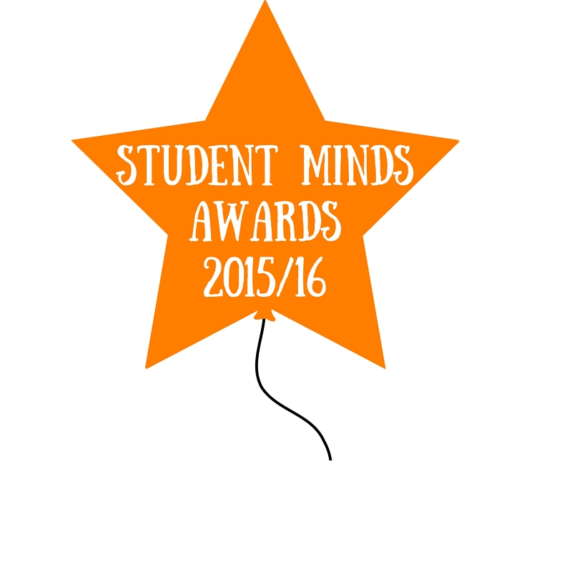
Student Minds Volunteer Awards 2015/16

Each year students involved with Student Minds campaign groups and peer support programmes can nominate their group to receive a Student Minds Award. These awards aim to celebrate our volunteers’ achievements over the last academic year.
Rewards
The winning group for each category will receive a certificate for the society and national recognition for your hard work. In addition:
- The ‘Group of the Year’ will receive £200, transferred to your group's account, to spend on future activities.
- All additional category winners will receive £50 transferred to your group's account.
Awards Categories
Every group that completes a nomination form will be entered into the 'Group of the Year' category. There is no limit on the number of nominations each group can make!

Group of the year 2015/16: Awarded to the group that has delivered the most successful or innovative initiatives to support student mental health and well-being.

Award for effective campaigning 2015/16: For the group that has delivered the strongest, most impactful or creative campaign on their campus.

Award for effective peer support 2015/16: For the peer support programme that can illustrate success in promoting their service, delivering safe sessions and receiving positive feedback. If you wish to be considered, please ensure your group has completed feedback stats for all of your group sessions.

Best event 2015/16: Awarded to the peer support or campaign group that delivered the most successful or creative event relating to student well-being.

Best fundraiser 2015/16: For the peer support programme or campaign group that delivered the most successful or creative fundraising activity (perhaps in partnership with other groups) to raise money for the national charity, Student Minds.

Nominating a Group
To nominate a group please complete the form below and return to emily@studentminds.org.uk by Monday 18th April 2016.
The Student Minds staff team, and an external member of staff working in student volunteering will score the entries against agreed criteria. The winners will be revealed at the Volunteers Festival on Tuesday 5th July 2016.

Awards Nomination Form

Name:
Role within group:
OR
Attendee (of an event or peer support group)
University:
Nominee: [group name]
Which award are you nominating
Please tell us why you think that your group/the group you are nominating should receive this award. What did you/they do?
(In approximately 200 words)
**For Student Minds volunteers nominating their group only**
What did you find most challenging about running this group/ programme/ activity?
How did you manage this?
(200 words)
Imagine we were using this nomination to write a press release about the group’s achievements. Tell us about the impact you feel the group had within the university community.
Please include numbers where possible and relevant (such as the number of people in attendance) and quotes from individuals about your group / activity.
(200 words)

Additional Evidence

Nominees are encouraged to provide as much additional evidence as possible. This can either be pasted into the box below or attached as separate files. We would particularly like to see the following:
- Photographs or videos of your group in action
- Links to local / student press articles about your group
- Supporting letters /emails from a university or students’ union staff member in support of your submission.
- Any formal reviews you have typed up about your group or an activity (perhaps information you are including in your group handover).

You may wish to post links to additional online content / videos or images here:

Please direct any questions about this form or the Awards Scheme to emily@studentminds.org.uk

